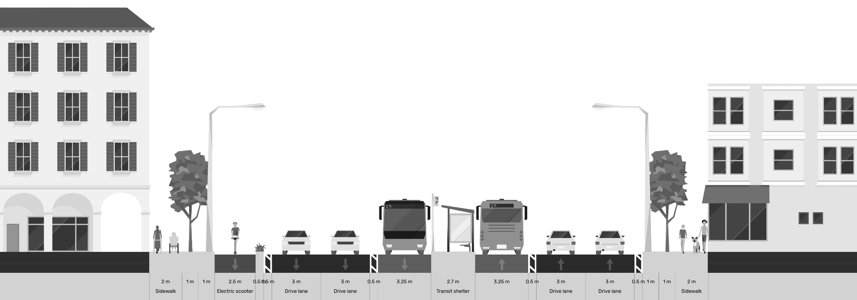

Conceptual Design and Due Diligence for the Yerevan Sustainable Urban Transport and Electric Mobility

Part of Output 8: Traffic and Parking Surveys and Analysis Report

June 23, 2026
Table of Contents
1 Executive Summary 5
2 Introduction 5
2.1 Purpose and Scope 5
2.2 Relationship to the Terms of Reference 5
3 Survey Methodology 6
3.1 Evolution of the Survey Approach 6
3.2 Adopted Methodology: Desk-Based Supply Inventory 6
3.3 Survey Instructions and Quality Control 7
3.4 Data Sources 7
4 Parking Supply Inventory Results 8
4.1 Aggregate Supply Summary 8
4.2 On-Street Parking by Regulatory Zone 9
4.3 On-Street Parking by Configuration 10
4.4 Signage 12
4.5 Marking 12
4.6 Corridor 1: Street-Level Detail 13
4.7 Corridor 2: Street-Level Detail 13
4.8 Corridor 3: Street-Level Detail 14
5 Parking Impacts of the Conceptual Corridor Designs 15
5.1 Nature of the Impact 15
5.2 Scale of Parking Removal 15
5.3 Impact by Sensitivity Zone 15
6 Displacement Assessment 16
6.1 Understanding Displacement 16
6.2 Available Absorptive Capacity 16
7 Occupancy and Demand: Field Survey Results 17
8 Conclusions 17

List of Figures
Figure 1 - Aggregate Supply Summary 8
Figure 2 - On-Street Parking by Regulatory Zone 9
Figure 3 - On-Street Parking by Configuration 10
Figure 4 - On-Street Parking by Location 11
Figure 5 - Parking Signage 12
Figure 6 - Marking 12
Figure 7 - Available Absorptive Capacity (Off-street) 16
Figure 8 - Available Absorptive Capacity (On-street) 16

List of TABLES
Table 1 - # of Parking Spaces 9
Table 2 - # of Parking Segments/Lots 9
Table 3 - On-Street Parking by Regulatory Zone 10
Table 4 - On-Street Parking by Configuration 11
Table 5 - On-Street Parking by Location 12
Table 6 - Corridor 1: Street-Level Detail 14
Table 7 - Corridor 2: Street-Level Detail 14
Table 8 - Corridor 3: Street-Level Detail 15
Table 9 - Impact by Sensitivity Zone 16

PROJECT SYNOPSIS

Project Name | TA-6559 REG: Implementing the Cities Development Initiative for Asia - Conceptual Design and Due Diligence for the Yerevan Sustainable Urban Transport and Electric Mobility Project (54128-001)
Country | Republic of Armenia
Geographic Area | City of Yerevan
Contract Number | S208439
Contracting Authority | Asian Development Bank (ADB)
Signed on | 26 August 2025
Commencement of service | 11 September 2025
Duration | 12 calendar months
End Date | 7 August 2026
CLient / EA | The Executing Agency (EA) is the Yerevan Municipality (YM)
PIU | The Yerevan Urban Development Programs Implementation Unit (PIU)
Funding Source | Cities Development Initiative for Asia Trust Fund, administered by ADB, through TA 6559-REG: Implementing the Cities Development Initiative for Asia approved on 8 September 2020.
Scope of Work | To develop: (i) bus public transport service Plan for Yerevan; (ii) Conceptual Design of three bus priority corridors; (iii) Upgraded depots to accommodate a fleet of battery electric buses; (iv) Traffic and Parking Management Plan; (v) Communications and Branding; and (vi) due diligence for ADB’s consideration of project financing.
Key Deliverables | Inception Report (followed by inception workshop)  Output 1: Memo describing selection of affected routes for further analysis  Output 2: Data collection methodology memo  Output 3: Raw and processed datasets for all collected data (Excel), including maps  Output 4: Network diagnostics PPT  Output 5: Service Plan PowerPoint and report, including high-quality, graphic-designed maps of the network, each route, and changes to existing routes  Output 6: Full conceptual-level designs for the bus priority corridors, bus stations, off-corridor stops, utilities, ITS, points along the off-corridor routes, and costings  Output 7: 3-D renderings of stations, with three different top structure architectural designs  Output 8: Traffic and parking surveys and analysis report  Output 9: Traffic Management Plan, including microsimulation  Output 10: Parking analysis report  Output 11: Report reviewing existing conditions at depots and future plans  Output 12: Conceptual design for both depots  Output 13: PPTs, handouts, and minutes from three public workshops  Output 14: Communication Strategy  Output 15: System brand including name and logo  Output 16: Stakeholder engagement plan  Output 17: IEE/EIA  Output 18: LARP  Output 19: Financial Management Assessment Report  Output 20: Financial Analysis Report and Linked Document  Output 21: Economic Analysis Report and Linked Document  Output 22: Strategic Procurement Plan  Output 23: Terms of reference  Output 24: Climate Risk and Adaptation Assessment  Output 25: Climate Change Assessment  Output 26: Poverty, Social and Gender Assessment Report  Output 27: Social Development and Gender Action Plan  Output 28: Institutional Assessment  Output 29: Institutional and Capacity Building Roadmap Output 30: Report on Knowledge Transfer Activities.
Consultant / Contractor | A+S Consult GmbH, Logit Consulting Inc, Exponent Engineers (Pvt.) Limited & POGHOS SHAHINYAN HAYKAZI
Contact | Team Leader: Wagner Colombini Martins, wagner.colombini@logiteng.com  Focal point: Lívia Delgado Rodrigues, livia.delgado@logiteng.com

Executive Summary
The Yerevan Sustainable Urban Transport and Electric Mobility Project is being prepared with support from the Asian Development Bank (ADB) through the Cities Development Initiative for Asia (CDIA). The project focuses on improving urban mobility through the introduction of three bus priority corridors totalling 34.6 kilometres, upgrading two trolleybus depots for 249 battery-electric buses, and implementing complementary traffic and parking management measures.
The three bus priority corridors are: Corridor 1 (11.66 km) starts near Bagratunyats (south) and runs northeast to Kentron; Corridor 2 (19.19 km) starts at Nor Nork (east) and runs west to Davtashen; and Corridor 3 (3.81 km) is a shorter segment in the south, possibly a branch or extension connecting the Sebastia/Malatia area. The conceptual designs involve the reallocation of street space, including dedicated bus lanes, improved pedestrian and non-motorised transport facilities, upgraded intersections, and public-realm improvements.
A targeted field occupancy survey has since been completed on six representative areas spanning the corridors' sensitivity range, surveyed on ordinary mid-week working days (29 May to 3 June 2026). It supplies the demand-side evidence previously unavailable. Across the surveyed areas, capacity-weighted peak occupancy reaches 93%, with 69% of zones exceeding the 85% efficiency threshold at the peak hour; parking is overwhelmingly short-stay (about 63% of vehicles stay one hour or less, 87% two hours or less) with turnover of 3.5 to 7.5 vehicles per marked space per day on the road-edge kerb; and peak displaced demand equals only 59% of the spaces removed (1,120 vehicles against 1,886 spaces in the surveyed areas), confirming with local measurement the international finding that displaced demand is materially lower than the supply removed. Occupancy readings above 100% are explained where they first appear: they mean more distinct vehicles used a kerb within the hour than it has marked spaces, not that the kerb was physically overfull at any one instant.
Basis of the impact figures. The parking-removal, retention and displacement figures in this report follow the v2 conceptual design and cover Corridors 1 and 2; Corridor 3 is withheld pending its conceptual design. They supersede the June draft's figures and will be updated again when the conceptual design is final.

Introduction

Purpose and Scope
This report constitutes the parking component of the Traffic and Parking Surveys and Analysis Report (Output 8). It documents the parking supply surveys conducted along and adjacent to the three bus priority corridors, presents the findings of the desk-based inventory and assesses the impacts of the conceptual corridor designs on parking.
The report should be read in conjunction with the standalone Parking Analysis Report (Output 10), which provides current context for parking management in Yerevan and provides potential mitigation measures for the displacement of parking places along the corridors.
This revision incorporates the results of a targeted field occupancy survey carried out after the desk-based inventory, on six representative areas. The deliverable therefore now presents both supply-side evidence (the inventory) and measured demand-side evidence (occupancy, duration, turnover and locally-measured displacement).

Relationship to the Terms of Reference
The ToR (Task 3, paragraphs 59–63) requires the Consultant to conduct a Parking Supply Survey documenting all on-street parking spaces and curb regulations along the bus priority corridors and for approximately 100 metres on every cross street, as well as all off-street parking spaces within a 100-metre radius of the corridors. The ToR further requires a Parking Occupancy Survey recording the number of parked vehicles at each hour, classified by vehicle type, to estimate turnover rates.
Following technical review and stakeholder discussions, the survey methodology was refined to prioritise a comprehensive desk-based parking supply inventory, supplemented by targeted demand analysis using municipal ANPR data where available. The justification for this methodological adjustment has been formally communicated to ADB and the PIU, and is summarised in Chapter 3 of this report.
The occupancy and duration component of the ToR, initially descoped on proportionality grounds, has subsequently been satisfied in representative form through this targeted field survey. The deliverable therefore meets the intent of the ToR rather than departing from it.

Survey Methodology

Evolution of the Survey Approach
The initial survey methodology envisaged a full-scale, corridor-wide field survey to document parking supply and occupancy patterns, including 17-hour observation windows, manual licence plate recording, and systematic logging of illegal parking. Following multiple rounds of technical discussions, iterative revisions of the methodology paper, and detailed review of implementation requirements, it became evident that such a comprehensive field operation would be both resource-intensive and disproportionate to the analytical needs of the assignment.
The primary purpose of this project is to support the design and implementation of bus priority infrastructure, which will significantly alter or in many cases fully remove existing on-street parking along the corridors. Under such conditions, detailed temporal parking characteristics (hourly occupancy profiles, turnover rates, duration patterns) have limited relevance, as the baseline parking situation will not be retained. The key planning challenge is not to optimise existing parking performance, but to understand the spatial distribution of parking supply and assess how displaced demand can be accommodated.
This position was subsequently revised. Rather than forgo occupancy evidence entirely, a proportionate field occupancy survey — six representative areas rather than the full 34 km — was conducted in late May and early June 2026, restoring the occupancy, duration and turnover evidence that the corridor design and the displacement assessment require. The areas were surveyed on four separate ordinary working days (Komitas, Friday 29 May; Shiraz/Hasratyan, Monday 1 June; Garegin Nzhdeh and Gai Avenue, Tuesday 2 June; Kentron and Malatia-Sebastia, Wednesday 3 June), with no weekend or public holiday; because the areas were spread across separate days rather than surveyed simultaneously, a one-off disruption would show as a localised outlier, whereas the behavioural patterns repeat across all six.

Adopted Methodology: Desk-Based Supply Inventory
The project team adopted a supply-led and spatially targeted analytical framework comprising three components:
Component 1: Desk-Based Parking Supply Inventory. A comprehensive spatial inventory of all on-street and off-street parking along and adjacent to corridors, developed using high-resolution digital tools including 360-degree street videos collected during project field missions (accessible at yerevan.omni7.app), recent Google Earth satellite imagery, and Yandex Maps street-level views. Two local surveyors were deployed remotely to systematically map and geo-reference every parking segment along the corridors and within the 100-metre cross-street influence area.
Component 2: Field Occupancy Survey (targeted). Hourly licence-plate sweeps from 07:00 to 24:00 across the six representative areas, recording for every parked vehicle the time, zone, plate, vehicle type, kerb location, parking method and legality. This provides the demand-side evidence — occupancy, duration and turnover — directly. (The municipal ANPR system maintained by Parking City Service CJSC remains available to the city for ongoing monitoring, but is not relied upon for the demand analysis in this report.)
Component 3: Targeted Field Verification. Quality assurance included a random cross-check of approximately 15% of the total surveyed parking spaces, with consultant staff independently verifying results against the video footage collected during the survey campaign. In addition, local staff conducted several on-the-spot field visits to selected locations to validate desk-based findings against real-time conditions on the ground.

Survey Instructions and Quality Control
Detailed survey instructions were prepared and distributed to the two local surveyors. The instructions specified the following protocols:
On-street parking (linear data): Surveyors created georeferenced paths in Google Earth for each parking segment. For parallel parking, capacity was calculated using the formula: Spaces = Length / 7.5 metres. For perpendicular (90°) and echelon (45°) parking, actual visible spots or parked cars were counted. Each segment was attributed with: number of spaces, parking angle (parallel/90/45), presence of signage (Yes/No), presence of marking (Yes/No), and location type (on-street/pocket/set-back).
Regulatory classification: Segments were colour-coded according to parking regulation status: Red for Zone A (paid), Blue for Zone B (paid), Yellow for no-parking/illegal zones (where vehicles park despite prohibition), and White for free parking. Segments were named using a standardised coding convention (e.g., Gai001, Gai002 for sequential legal segments on Gai Street).
Off-street parking (polygon data): Off-street facilities were mapped using polygon tools in Google Earth, with capacity estimated using the formula: Spaces = Total Area (sqm) / 30. Only publicly accessible parking was recorded; private fenced lots such as those for “employees only” were excluded.

Data Sources
- 360-degree street video footage from project field missions (yerevan.omni7.app)
- Google Earth satellite imagery and the project GIS layer (shared KML project file)
- Yandex Maps street-level imagery for verification of parking conditions, signage, and road markings

Parking Supply Inventory Results

The complete results of the desk-based parking supply inventory are presented on the interactive web platform at https://yerevan-parking.vercel.app and are derived from the GeoJSON dataset containing geo-referenced features. The key summary findings are presented below.

Aggregate Supply Summary
The survey documented a total of 14,557 parking spaces across Corridors 1 and 2 and their 100-metre influence areas, comprising 7,825 on-street spaces (across 606 line segments) and 6,732 off-street spaces (across 239 polygon areas with recorded capacity). Corridor 3 is not included in this total: its conceptual design has not been prepared, so it is withheld from the assessment. For the record, the inventory found 896 on-corridor on-street spaces along Corridor 3.
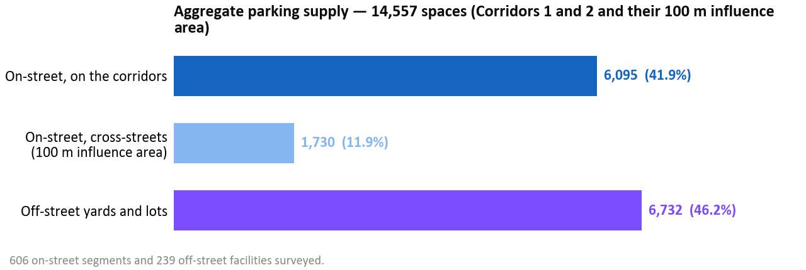
Figure 1 - Aggregate parking supply, Corridors 1 and 2 with their 100 m influence area

Table 1 - # of Parking Spaces
Parameter | On-Street | Off-Street | Total
Total spaces | 7,825 | 6,732 | 14,557
Corridor 1 | 2,349 | -
Corridor 2 | 3,746
Cross-streets | 1,730 |  | 1,730
Yards |  | 6,732 | 6,732

Table 2 - # of Parking Segments/Lots
Features surveyed | 606 segments | 239 facilities

*Below sub-chapters provide information about parking spaces strictly on the corridor space without accounting for the 100-m “buffer” territory.*

On-Street Parking by Regulatory Zone
Of the 6,095 on-street spaces surveyed along the corridors, the vast majority (5,248 spaces, 86.1%) have no payment zone classification, reflecting the predominance of free parking in the city. Only 780 spaces (12.8%) are within the paid parking system managed by Parking City Service CJSC. An additional 67 spaces (1.1%) were identified as specialized locations for taxi drivers.
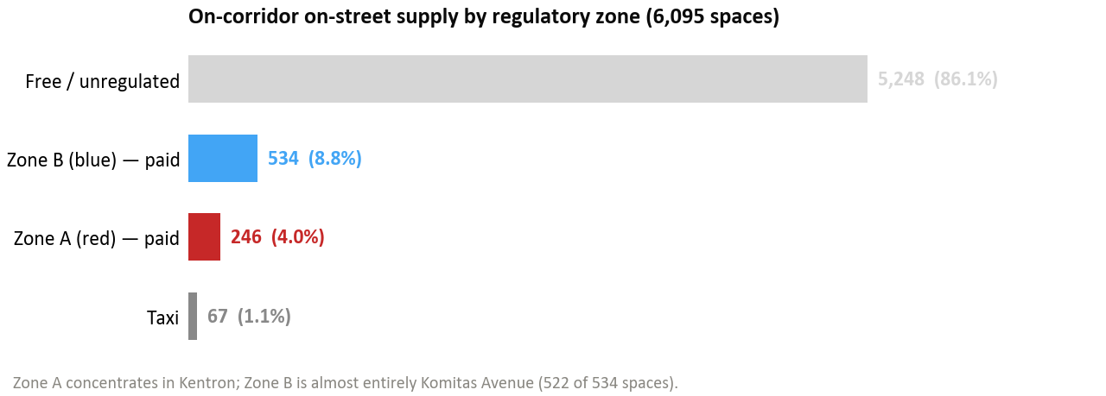
Figure 2 - On-corridor on-street supply by regulatory zone

Table 3 - On-Street Parking by Regulatory Zone
Zone Classification | Spaces | Share of Total
Zone A (Red) – paid | 246 | 4.0%
Zone B (Blue) – paid | 534 | 8.8%
Taxi | 67 | 1.1%
Free | 5,248 | 86.1%
Total | 6,095 | 100%

Zone A spaces are concentrated in the Kentron district along Corridor 1, primarily on Nalbandyan (69 spaces), Tigran Mets (47), Abovyan (46), Amiryan (43), Agatangeghos (21) and Moskovyan (20). Zone B spaces are almost entirely on Komitas Avenue (522 of the 534 Zone B spaces) along Corridor 2, with a small remainder on Vagharshyan (12).

On-Street Parking by Configuration
Table 4 - On-Street Parking by Configuration
Parking Method | Spaces | Share
Parallel | 4,655 | 76.4%
Perpendicular (90°) | 1,440 | 23.6%
Total | 6,095 | 100%

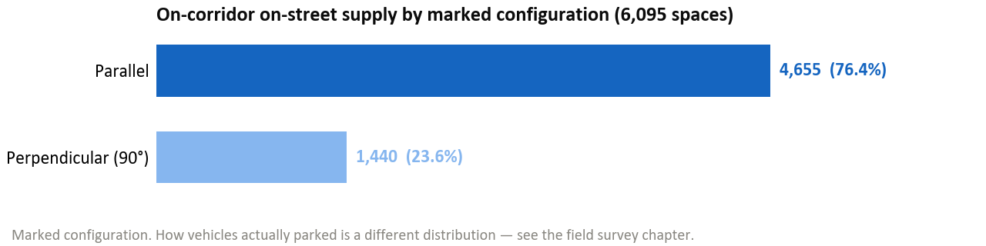
Figure 3 - On-corridor on-street supply by marked configuration

Table 5 - On-Street Parking by Location
Location Type | Spaces | Share
On-street (road edge) | 4,394 | 72.1%
Pocket (inset into curb) | 1,431 | 23.5%
Set-back (separated from road) | 270 | 4.4%
Total | 6,095 | 100%

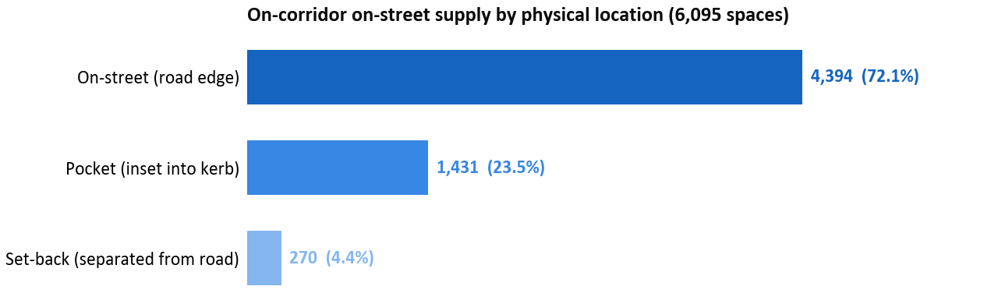
Figure 4 - On-corridor on-street supply by physical location

The predominance of parallel parking (76.4%) and on-street location (72.1%) reflects the typical curbside parking pattern along arterial corridors. The significant volume of 90° perpendicular parking (1,440 spaces, 23.6%) indicates areas where parking has expanded beyond parallel configurations, often without formal markings.
The inventory above records marked configuration; the field survey additionally recorded how vehicles actually parked, and the two do not agree. By vehicle, 60% parked parallel, 27% at 45° and 13% perpendicular — even though no 45° parking is marked anywhere on the corridors, so more than a quarter of observed parking uses a layout the inventory does not record at all. About 21% of observed parking sat off the carriageway (14.3% on footpaths and 6.7% in setbacks) — informal encroachment the supply map does not capture, highest in Malatia-Sebastia (30.9%) and Garegin Nzhdeh (30.4%), lowest in Kentron (10.0%) where the kerb is most tightly built. Legality was recorded for every vehicle: only about 0.2% was flagged as illegally parked, indicating that the kerbside problem is saturation and tolerated informality rather than overt illegality.

Signage
Only 1,201 of the 6,095 on-street spaces (19.7%) have visible parking signage. The remaining 4,894 spaces (80.3%) lack formal signage, confirming that the vast majority of parking along the corridors operates without clear regulatory indication to drivers.
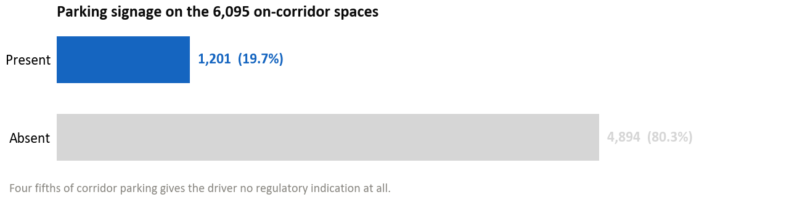
Figure 5 - Parking signage coverage

Marking
Only 856 of the 6,095 on-street spaces (14.0%) have visible parking markings on the pavement. The remaining 5,239 spaces (86.0%) lack formal marking.
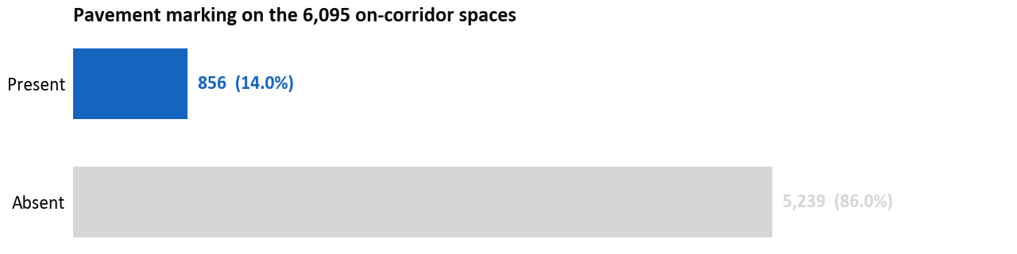
Figure 6 - Pavement marking coverage

Corridor 1: Street-Level Detail
Corridor 1 (11.66 km) accounts for 2,349 on-corridor on-street spaces, a further 489 on-street spaces on cross-streets within the 100-metre influence area, and 3,040 off-street spaces in 83 facilities — 5,878 spaces in total within the survey area.
Table 6 - Corridor 1: Street-Level Detail
Street | On-Street Spaces | Segments
Arshakunyats Avenue | 1,181 | 68
Bagratunyats | 331 | 19
Nalbandyan | 252 | 19
Garegin Nzhdeh | 171 | 9
Abovyan | 154 | 26
Amiryan | 84 | 21
Tigran Mets | 76 | 15
Moskovyan | 46 | 7
Agatangeghos | 30 | 4
Arshakunyats 1st | 24 | 3
Total | 2,349 | 191

Major off-street facilities along the Corridor 1 include the Yerevan Mall area (145 spaces), the Arshakunyats Tonavachar complex (107 spaces), the Agatangeghos Ayrarat facility (92 spaces), and numerous residential yard areas.

Corridor 2: Street-Level Detail
Corridor 2 (19.19 km) accounts for 3,746 on-corridor on-street spaces, a further 1,241 on-street spaces on cross-streets within the 100-metre influence area, and 3,692 off-street spaces in 156 facilities — 8,679 spaces in total within the survey area.
Table 7 - Corridor 2: Street-Level Detail
Street | On-Street Spaces | Segments
Raffi | 766 | 14
Komitas Avenue | 539 | 59
Rubinyan | 517 | 34
Sebastia | 461 | 29
Qrq Qrqoryan | 298 | 25
Grigor Hasratyan | 276 | 19
Davit Anhaght | 274 | 21
Kievyan | 219 | 9
Shiraz | 168 | 13
Gai | 157 | 12
Vazgen Sargsyan (City) | 30 | 1
Vazgen Sargsyan / Mher Mkrtchyan Sq. | 17 | 3
Vagharshyan | 12 | 1
Barekamutyun | 6 | 1
Kievyan 1st | 6 | 1
Total | 3,746 | 242

Major off-street facilities along the Corridor 2 include the Zeytun City complex (145 spaces), the Komitas City facility (123 spaces), and numerous residential yard areas throughout the Sebastia, Komitas, and Kievyan segments.

Note: the street-level tables in this section are complete — every on-corridor segment is attributed to a street, so each table sums exactly to that corridor's on-corridor total (2,349 and 3,746 spaces). A handful of segment names carrying obvious spelling variants in the survey data have been folded into the correct street.

Parking Impacts of the Conceptual Corridor Designs

Nature of the Impact
The conceptual corridor designs reallocate the whole cross-section. Along much of the alignment the dedicated bus lanes run in the central median; along other sections they run kerbside. That distinction matters for where passengers board — an island platform in the carriageway rather than a stop on the footway — but it does not drive the parking impact. A kerb-aligned bus lane occupies the very kerbside space that parking occupies, and so removes as much on-street parking as a median-aligned one; in station areas it removes slightly more. The parking loss follows from reallocating the full right-of-way to bus lanes, general traffic, cycle lanes and adequate footways, not from the choice of alignment. The cross-sections allocate carriageway width to dedicated bus lanes (2 × 3.5 m), mixed-traffic lanes (2 × 3.0 m per direction), median platforms and separators (0.5 m buffers), cycle lanes, and minimum sidewalk widths of 2.50 m on each side. Where the existing right-of-way is fully consumed by that allocation no kerbside parking can be retained, and this is the case along most of the alignment. Between stations, however, the cross-section is less demanding, and in most such sections there is room for parking to remain. That is why the design retains or re-establishes 1,220 spaces (20% of the on-corridor supply) rather than removing all of it: the removal figure is 80%, not 100%.

Scale of Parking Removal
Setting the supply inventory against the v2 conceptual design, the bus priority corridors remove 4,875 of the 6,095 on-corridor on-street spaces (80%) and retain or re-establish 1,220 (20%). Corridor 1 loses 1,480 of 2,349 spaces, retaining 869; Corridor 2 loses 3,395 of 3,746, retaining 351. The retained spaces sit off the running way — in pockets, setbacks and bays re-established between stations — rather than on the carriageway itself. The breakdown by sensitivity zone is as follows:
Basis and status of these figures. The parking-impact figures in this chapter follow the v2 conceptual design and cover Corridors 1 and 2 only; Corridor 3 is withheld from the impact assessment because its conceptual design has not yet been prepared. Because the conceptual design is not final, the removal and retention figures — and the displacement figures that follow from them — will be updated when the design is signed off. They are the current best estimate, not a final count, and they supersede the figures given in the June draft, which were based on an earlier design revision and on all three corridors.
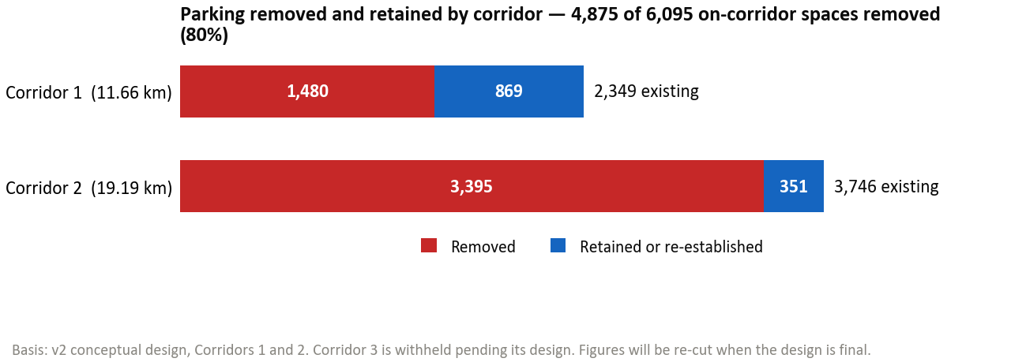
Figure 7 - Parking removed and retained by corridor

Impact by Sensitivity Zone
Table 8 - Impact by Sensitivity Zone
Sensitivity | Corridor Segments | On-Street Spaces | Key Concern
High | Komitas Avenue (539), Nalbandyan (252), Abovyan (154), Amiryan (84), Tigran Mets (76) and 2 further streets | 1,181 | Zone A and Zone B pricing; limited side-street capacity; competing commercial demands. Field survey: Kentron 138% peak with only 10% absorbable on-street; Komitas 123% peak with 0% on-street absorption — Komitas is reclassified from medium to high on this evidence.
Medium | Arshakunyats Avenue (1,181), Davit Anhaght (274), Kievyan (219), Garegin Nzhdeh (171) and 2 further streets | 1,875 | Mixed residential, commercial and arterial functions; some absorptive capacity on parallel streets. Field survey: Garegin Nzhdeh 92% peak / 30% absorption.
Lower | Raffi (766), Rubinyan (517), Sebastia (461), Bagratunyats (331), Qrq Qrqoryan (298) and 7 further streets | 3,039 | Predominantly free and unmarked; suburban; more flexible accommodation. Field survey: Shiraz/Hasratyan 75% / 69%, Malatia-Sebastia 54% / 97% — confirmed lower.

Displacement Assessment

Understanding Displacement
Parking displacement refers to the relocation of parking demand from the corridor to adjacent streets, off-street facilities, or alternative modes when on-street supply is removed. International experience with European BHLS corridors (Nantes, Metz, Rouen, Eindhoven, Helsingborg) consistently demonstrates that actual displaced demand requiring physical accommodation is typically lower than the number of spaces removed, due to modal shift, behavioural adaptation, and the elimination of informal parking.
Locally measured. Across the surveyed areas, peak displaced demand was 1,120 vehicles against 1,886 spaces removed — 59%. That percentage is the measured displaced demand set against the supply removed in the same six areas, and it is worth stating precisely what each side of it is. Displaced demand is the number of distinct vehicles observed parking in the zones the conceptual design removes, counted at each area's own busiest hour and summed across the six areas (1,120 vehicles). The denominator is the formal capacity removed in those same zones (1,886 spaces). The ratio is below 100% because the kerb is not full everywhere at the same time: fewer vehicles actually need re-homing than there are spaces being taken away. It is a demand overlay on six representative areas rather than a corridor-wide re-survey, and it should not be read as meaning that 41% of the removed supply was unused — only that at no single hour were all of those spaces occupied at once. The principle that displaced demand falls well below the supply removed is therefore now measured in Yerevan, not merely inferred from European precedent.

Available Absorptive Capacity
The survey identified substantial off-corridor capacity that can serve displaced demand if proper political will and administrative efforts are commited:
- 6,732 off-street spaces within the 100-metre influence area of Corridors 1 and 2. This stock is overwhelmingly gated residential courtyard rather than public parking: courtyards are 217 of the 239 facilities (91%) and 5,601 of the 6,732 spaces (83%); the balance is 22 named commercial and institutional lots, which are individually about twice the size of a courtyard
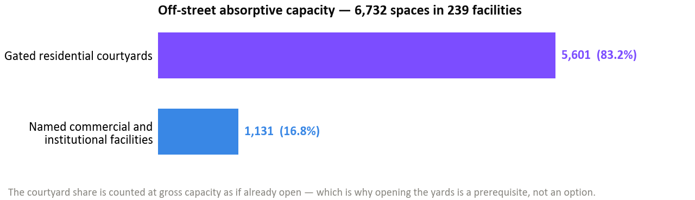
Figure 8 - Available absorptive capacity (off-street)
- 1,730 on-street spaces on cross-streets within the influence area, many of which are currently underutilised and could accommodate additional demand through formal delineation (1,505 of these spaces are still free to park and the city could turn them into Zone A/B paid parking).
- Measured absorption (surveyed areas). Of the peak displaced demand, surviving on-street capacity absorbs about 35% (10% in the Kentron core, 0% in Komitas, up to 97% in Malatia-Sebastia). The balance is closed by off-street capacity — but 83% of the absorptive capacity counted (1,935 of 2,326 spaces) is off-street rather than kerbside, and that off-street stock is 91% gated residential courtyard by facility count (83% by capacity), counted at gross capacity as if already open. The conclusion that displaced demand can be re-absorbed (approaching 100% in aggregate) is therefore conditional on those yards being opened and actively managed; this dependency, and the measures to address it, are carried in the companion Parking Analysis Report (Output 10).
- Measured off-street occupancy (field survey). The off-street side of this balance is now partly observed, not only inventoried. In each of the six areas the survey recorded hourly occupancy in one representative off-street facility (427 surveyed spaces in total) using the same licence-plate method as on-street. Averaged across the day these accessible facilities run about 52% full, so real off-street headroom demonstrably exists. At the peak hour, however, three of the six are already at or beyond their marked capacity (Palace 194%, Nalbandyan 142%, Komitas City 101%) and only three keep meaningful spare (Garegin 45%, Shiraz 59%, Sebastia 77%). These surveyed facilities are accordingly excluded from the absorptive-capacity figure above — they already carry their own demand — so the courtyard dependency refers to the still-closed residential yards that could not be surveyed.
Area | Surveyed off-street facility | Formal spaces | Avg. occupancy | Peak-hour occupancy
Kentron (Corridor 1 core) | Nalbandyan yard | 60 | 81% | 142%
Komitas Avenue | Komitas City lot | 123 | 56% | 101%
Garegin Nzhdeh | GN off-street | 40 | 22% | 45%
Gai Avenue (Mega Mall) | Palace lot | 32 | 115% | 194%
Malatia-Sebastia | Sebastia yard | 101 | 32% | 77%
Shiraz / Hasratyan | Shiraz off-street | 71 | 37% | 59%
All six (total / weighted avg.) | — | 427 | 52% | —

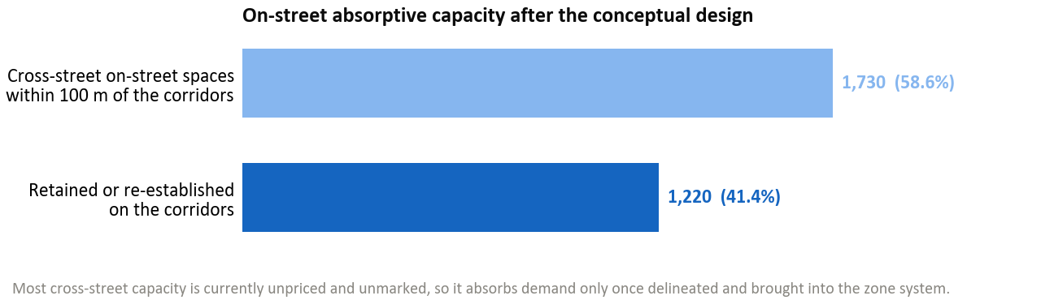
Figure 9 - Available absorptive capacity (on-street)

Field Occupancy Survey: Methodology, Locations and Results
The demand-side evidence in this report comes from a targeted field occupancy survey carried out after the desk-based supply inventory. This chapter documents how it was designed, where it was conducted and what it measured, and then presents the results broken down by area and by parking typology. The aggregate headlines are that capacity-weighted peak occupancy across the surveyed areas reaches 93%, that 69% of surveyed zones exceed the 85% efficiency threshold at their peak hour, and that the kerb is short-stay and high-turnover. Those aggregates conceal a range from 54% to 138%, however, and it is the range rather than the average that determines what mitigation each part of the corridor needs.

Survey Design and Instrument
The survey was a rolling licence-plate census rather than a spot count. Enumerators walked a fixed circuit of numbered survey zones once an hour from 07:00 to 24:00, recording every parked vehicle on each pass. Recording the plate rather than only a headcount is what makes duration, turnover and displacement measurable: a plate seen in consecutive hours is one vehicle staying, whereas the same space occupied by successive plates is turnover, and a headcount cannot tell the two apart.
For every parked vehicle the enumerator recorded seven fields: the hour of observation; the survey zone; the licence plate; the vehicle type (sedan, truck or motorcycle); where the vehicle stood relative to the carriageway (on the carriageway, on the footpath, or in a setback); how it was parked (parallel, 45 degrees, or perpendicular); and whether the parking was legal or illegal. The last three fields are what allow the results to be broken down by typology rather than reported only in aggregate, and they are what reveal where observed behaviour departs from the marked supply.
Occupancy is measured against the formal (striped) capacity already recorded in the supply inventory, so the demand and supply sides share a single denominator. Where a segment has no marked bays, capacity is the inventory estimate of one space per 7.5 metres of parallel kerb. A parking event, the unit behind turnover, is one continuous run of hours in which a plate is present; a gap of more than one hour is treated as the space having been vacated and re-used. In total the survey produced 21,186 on-street vehicle sightings covering 10,135 distinct vehicles across 136 survey zones, plus one off-street facility in each of the six areas.
How occupancy is measured, and what a figure above 100% means. Occupancy in this report is the number of distinct vehicles recorded using a length of kerb during an hour, divided by the number of spaces on it. It is an hour-long count rather than an instantaneous snapshot, so a reading above 100% does not mean the kerb was physically overfull at any one moment: it means more distinct vehicles used that kerb within the hour than there are spaces, because the spaces turned over. Two further effects lift on-street readings above 100%. Vehicles parked outside the marked bays are counted against the marked capacity — 14.3% of observed vehicles stood on footpaths and 6.7% in setbacks — and where no bays are marked at all (86% of the corridor kerb) the denominator is an estimate of capacity, one space per 7.5 metres of parallel kerb, rather than a count of stripes. Off-street the same turnover effect applies, with stacking on top of it: vehicles stand in aisles and against walls in facilities whose capacity is estimated from area at 30 m² per space. That is how the Palace lot reaches 194% and the Nalbandyan yard 142% at their peak hour. A figure above 100% is therefore a reliable signal of saturation and of parking spilling beyond the marked supply — it is not a data error, and it is not a measure of illegal parking, which was separately recorded and is only 0.2% of observations.
Two limits of the instrument should be stated at the outset. The window closes at midnight, so true overnight-residential demand is under-counted and the residential long-stay tail visible in the data is a lower bound. And payment compliance cannot be observed by an enumerator on foot, because whether a session was paid for is held only in the Parking City Service back-office. These are the two dimensions for which the municipal ANPR record, if released, would still add value.

Where and When the Surveys Were Conducted
Six areas were surveyed rather than the full 34 km of corridor. They were chosen to span the corridors' sensitivity range: a dense commercial core under paid regulation (Kentron), the city's largest Zone B concentration (Komitas Avenue), a retail-anchored destination (Gai Avenue at Mega Mall), a mixed residential and commercial arterial (Garegin Nzhdeh), and two outer residential areas (Shiraz/Hasratyan and Malatia-Sebastia). Between them they cover the full range of regulatory status, land use and kerb pressure found along the corridors, which is what the displacement assessment requires.
The areas were surveyed on four separate ordinary mid-week working days between 29 May and 3 June 2026, with no weekend or public holiday. Spreading them across days rather than surveying simultaneously was deliberate: a one-off disruption on any single day would show up as a localised outlier against the other areas, whereas a behavioural pattern that repeats across four separate days in six separate places is a pattern. The table below sets out the survey footprint.
Table 9 - Field occupancy survey: areas, dates and footprint
Area | Survey date | Day | Zone codes | Survey paths | Formal spaces | Corridor
Kentron (Corridor 1 core) | 3 June 2026 | Wednesday | K01–K58 | 58 | 586 | 1
Komitas Avenue | 29 May 2026 | Friday | 70–122 | 53 | 450 | 2
Gai Avenue (Mega Mall) | 2 June 2026 | Tuesday | 60–69 | 10 | 132 | 2
Garegin Nzhdeh | 2 June 2026 | Tuesday | 25–56 | 31 | 451 | 1
Shiraz / Hasratyan | 1 June 2026 | Monday | 123–156 | 34 | 439 | 2
Malatia-Sebastia | 3 June 2026 | Wednesday | 2–23 | 22 | 872 | 2
All six areas | 29 May to 3 June 2026 | 4 working days | - | 208 | 2,930 | 1 and 2

Occupancy Results by Area
Capacity-weighted peak occupancy across all six areas is 93%, 69% of the 136 surveyed zones exceed the 85% efficiency threshold at their peak hour, and 116 zones are over capacity outright. The aggregate is not the operative number, because the six areas differ by a factor of nearly three. Kentron runs at 138% and Malatia-Sebastia at 54%: the first has no slack at all, the second has a great deal. Three of the six areas, Kentron, Komitas and Gai Avenue, are over capacity at the peak hour, and those are precisely the areas where displaced demand cannot simply move to the next street.
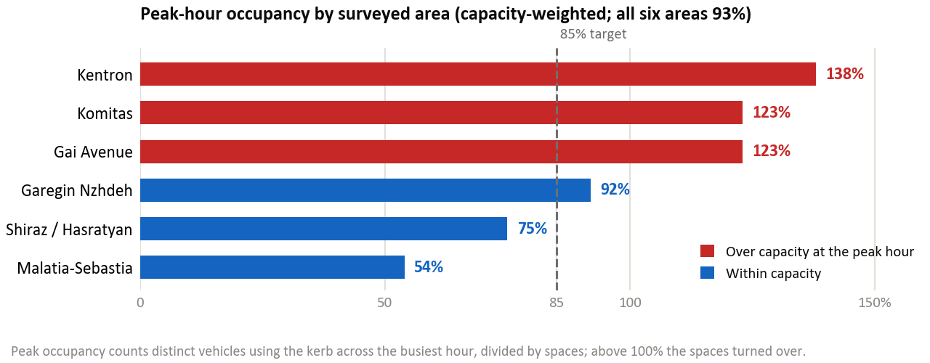
Figure 10 - Peak-hour occupancy by surveyed area
Table 10 - Occupancy, stay and turnover by surveyed area
Area | Peak occupancy | Zones over 85% | Zones over capacity | Average stay | Turnover per space/day
Kentron (Corridor 1 core) | 138% | 89% | 42 | 2.2 h | 7.5
Komitas Avenue | 123% | 81% | 34 | 1.8 h | 5.5
Gai Avenue (Mega Mall) | 123% | 90% | 7 | 2 h | 6.6
Garegin Nzhdeh | 92% | 61% | 15 | 1.7 h | 5.3
Shiraz / Hasratyan | 75% | 47% | 13 | 1.6 h | 3.7
Malatia-Sebastia | 54% | 27% | 5 | 1.6 h | 3.5
All six areas | 93% | 69% | 116 | 1.8 h | 3.5 to 7.5

The demand profile through the day explains why a single peak figure is adequate for the displacement assessment. Occupancy rises steeply from 07:00, plateaus across the working day, and holds late: the evening does not empty the kerb, because the residential and commercial peaks overlap rather than alternate. There is no quiet hour into which displaced demand could be shifted by timing measures alone.
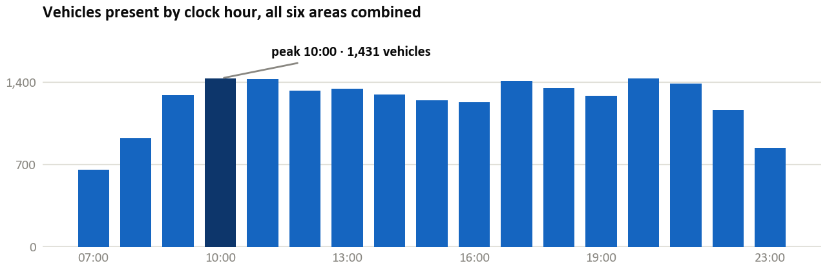
Figure 11 - Vehicles present by clock hour, all six areas combined

Results by Parking Typology
The survey recorded how each vehicle was parked as well as that it was parked, which allows the results to be broken down by typology. Three breakdowns matter for the corridor design: how vehicles are arranged, where they stand relative to the carriageway, and what kind of vehicle they are.
Configuration: the marked supply understates angled parking. The inventory records the corridor kerb as 76.4% parallel and 23.6% perpendicular, with no 45-degree parking marked anywhere along either corridor. The survey found 60% of vehicles parked parallel, 27% at 45 degrees and 13% perpendicular. More than a quarter of observed parking therefore uses a layout that does not exist in the marked supply at all. That is a finding rather than a discrepancy: where bays are unmarked, drivers self-organise into whichever angle fits the most cars, which is why delineating the existing free parking recovers usable capacity without adding any.
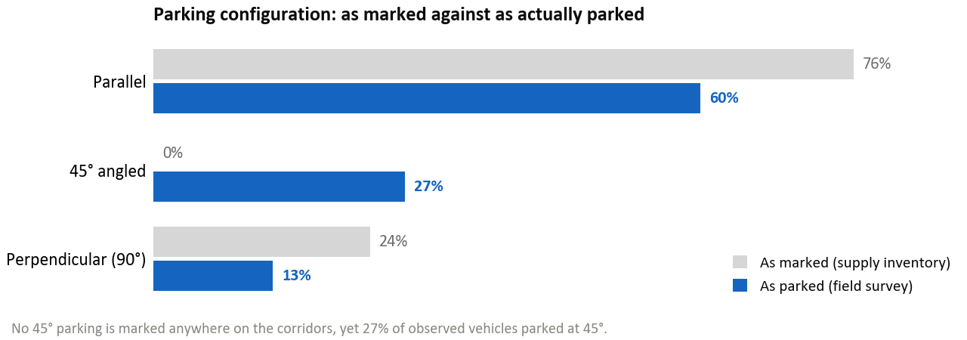
Figure 12 - Parking configuration: as marked against as actually parked
Kerb location: a fifth of parking is not on the carriageway. Across the six areas 21% of observed vehicles stood off the carriageway, 14.3% on footpaths and 6.7% in setbacks. This is informal encroachment the supply inventory does not capture, and it varies sharply by area: it reaches 30.9% in Malatia-Sebastia and 30.4% in Garegin Nzhdeh, where footway parking is routine, and falls to 10.0% in Kentron, where the kerb is too tightly built to allow it. Footway parking is the component with a direct pedestrian and accessibility cost, and it is concentrated in the outer areas rather than in the centre. It is also distinct from illegality: only 0.2% of observations were recorded as illegal, so footway parking in these areas is tolerated rather than enforced against.
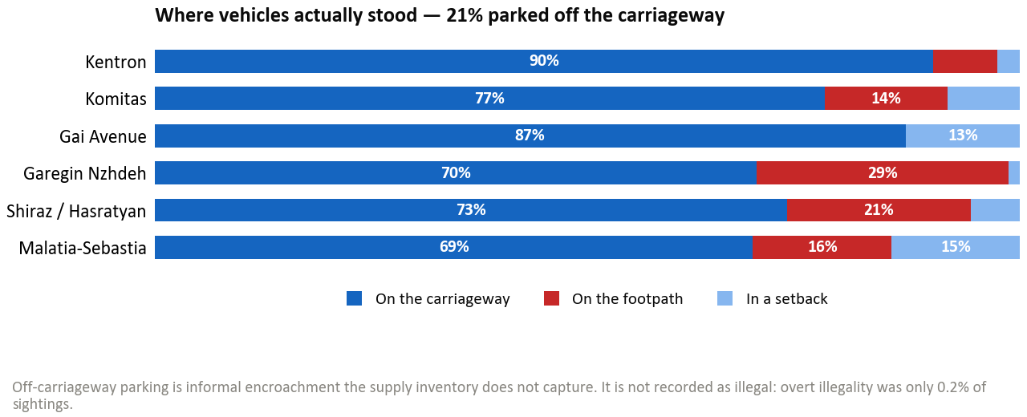
Figure 13 - Where vehicles actually stood, by area
Vehicle type: freight is concentrated in pockets. Sedans account for 94.8% of observed vehicles and motorcycles for 0.3%. Trucks are 4.9% of all classified vehicles across the six areas, but the distribution is what matters: the truck share reaches 12.6% in Malatia-Sebastia (548 of 4,339 vehicles) and 8.0% in Shiraz/Hasratyan, against 1.7% in Kentron. Loading provision should therefore be sized to those measured pockets rather than distributed uniformly along the corridors.
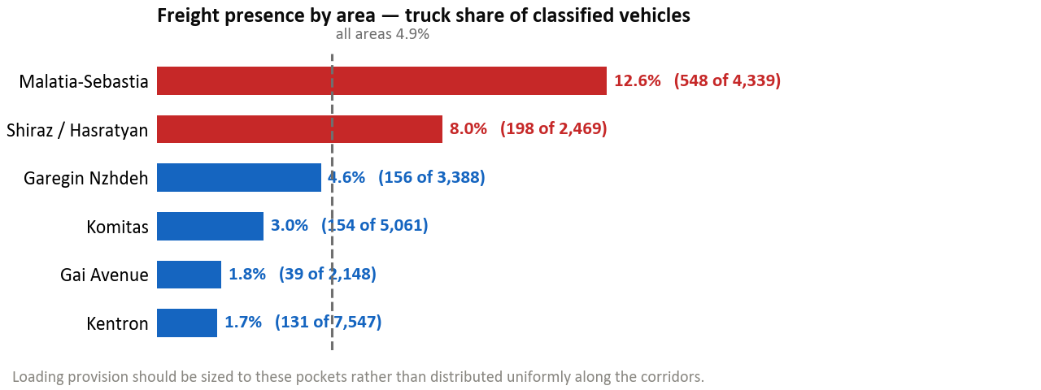
Figure 14 - Freight presence by area

Duration of Stay and Turnover
The corridor kerb is dominated by short visits. About 63% of stays are one hour or less and 87% are two hours or less, while genuine all-day storage of eight hours or more is about 7% and the intermediate worker-length stay of two to eight hours about 6%. The average stay is 1.8 hours. This distribution is stable across all six areas, which is the strongest single behavioural finding of the survey: the kerb serves visitors and errands, not commuters.
It matters for mitigation because it inverts the intuitive policy response. A kerb dominated by all-day commuter storage is fixed with maximum-stay limits; a kerb that already turns over every hour is not, and imposing visitor caps on it would regulate the very behaviour the policy wants. Pricing, delineation and off-street supply are the levers that bind here. The long-stay tail that does exist is largely residential and overnight, and the daytime window under-counts it.
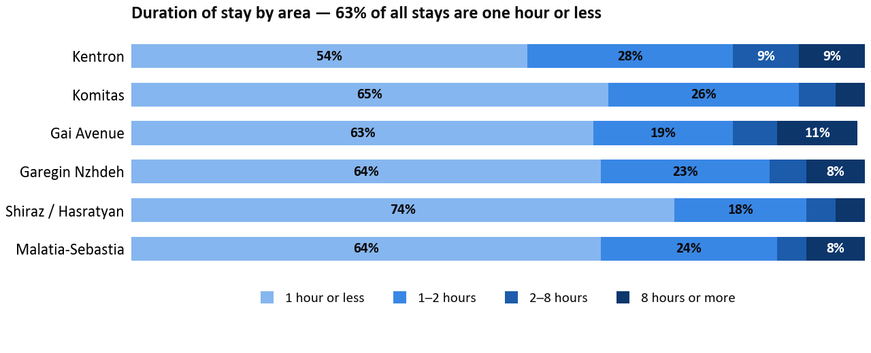
Figure 15 - Duration of stay by area
Turnover follows directly from the duration mix. Measured as parking events per marked space per day across all bay types, it runs from 3.5 in Malatia-Sebastia to 7.5 in Kentron, where the busiest kerb recycles each space between seven and eight times a day. The gradient tracks land use rather than regulation: the commercial core and the retail destination turn over fastest, the outer residential areas slowest, and the paid Zone B on Komitas sits between them at 5.5.
A note on the basis, because an earlier figure circulated. Turnover here is measured across all bay types — road-edge kerb, pockets and setbacks together — so every area rests on at least 132 marked spaces. An earlier draft quoted a range of 3.1 to 11.5 per space per day, measured on the road-edge kerb alone. That calculation is arithmetically correct and is reproduced in the underlying data, but its two highest values are not reliable: Gai Avenue has only 6 road-edge spaces and Malatia-Sebastia only 4, essentially all of their parking being in pockets and setbacks, so those ratios rest on denominators too small to carry a figure. On the four areas that do have a substantial road-edge kerb the two bases sit close together — Komitas 5.7 against 5.5, Garegin Nzhdeh 5.2 against 5.3, Shiraz/Hasratyan 3.1 against 3.7, with Kentron the widest at 6.1 against 7.5. The all-bay-type range is used throughout this report.
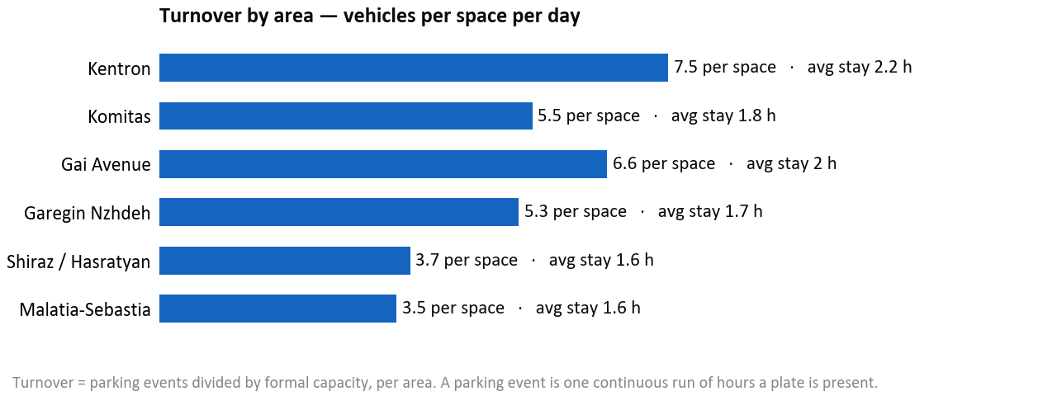
Figure 16 - Turnover by area

Measured Displacement by Area
Because the survey recorded which zones the conceptual design removes, displacement can be measured rather than assumed. Across the six areas the design removes 1,886 spaces, in which 1,120 distinct vehicles were observed at the areas' respective peak hours, or 59% of the supply removed. The per-area picture is far more uneven than that aggregate, and the unevenness is the finding: displaced demand runs from 27% of removed supply in Malatia-Sebastia to 99% at Gai Avenue, and the share that surviving nearby on-street capacity can re-absorb runs from 0% in Komitas to 97% in Malatia-Sebastia.
The two dimensions do not move together, and that is what drives the sensitivity banding. Kentron and Komitas combine high displaced demand with almost no on-street capacity to receive it, so their mitigation has to be off-street. Shiraz/Hasratyan and Malatia-Sebastia combine modest displacement with ample nearby kerb, so delineation and organisation suffice. Gai Avenue is the outlier: displaced demand is essentially the whole removed supply, and even filling every nearby facility leaves a residual, which is why its kerb parking is left in place for now and revisited as the area develops.
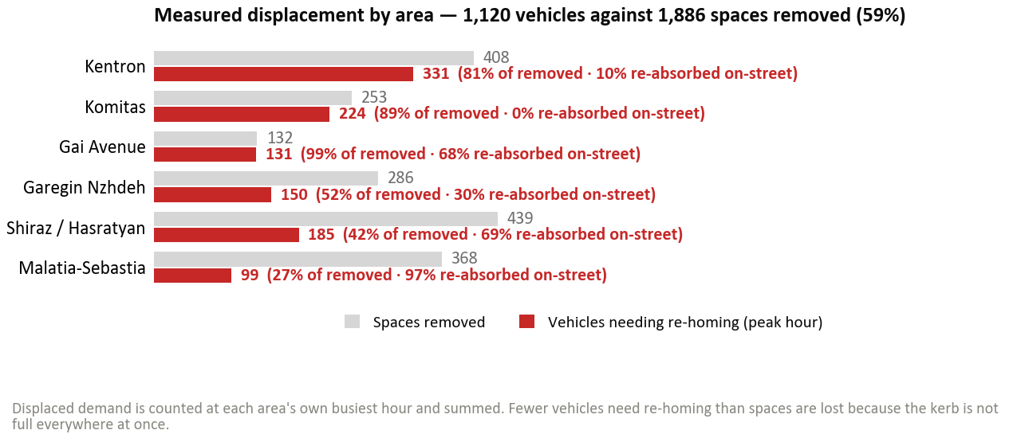
Figure 17 - Measured displacement by area
Table 11 - Measured displacement and absorption by area
Area | Spaces removed | Displaced at peak | Displaced as % of removed | Nearby on-street | Absorbed on-street | Nearby off-street
Kentron (Corridor 1 core) | 408 | 331 | 81% | 34 | 10% | 395
Komitas Avenue | 253 | 224 | 89% | 0 | 0% | 482
Gai Avenue (Mega Mall) | 132 | 131 | 99% | 89 | 68% | 27
Garegin Nzhdeh | 286 | 150 | 52% | 45 | 30% | 451
Shiraz / Hasratyan | 439 | 185 | 42% | 127 | 69% | 387
Malatia-Sebastia | 368 | 99 | 27% | 96 | 97% | 193
All six areas | 1,886 | 1,120 | 59% | 391 | 35% | 1,935

What the Survey Cannot Observe
Three limits bound what the results above can carry. The survey window runs to midnight, so true overnight-residential demand is under-counted and the residential long-stay share should be read as a lower bound; this matters most in Malatia-Sebastia, whose daytime pressure is the lowest of the six but whose long-stay signature is the strongest. Payment compliance was not observable, so the survey cannot say what share of vehicles in Zone A and Zone B had paid; that would require the Parking City Service back-office record. And six areas are not the whole corridor: the displacement figures are a demand overlay on representative areas rather than a corridor-wide census, and they are stated as such wherever they appear.
One further check is worth recording because it returned a negative result. The plate log allows long-term stationary vehicles to be identified, since a plate present in every hourly sweep of the window has not moved all day, which is the cheapest observable proxy for a stored or abandoned vehicle. Across all six areas only 5 vehicles of the 10,135 observed met that test. On this evidence long-term vehicle storage and abandonment are not a material component of corridor kerb demand, and the kerb pressure documented in this chapter is genuine in-use demand.

Conclusions
The parking supply inventory for the Yerevan bus priority corridor project provides a comprehensive, georeferenced evidence base covering 14,557 parking spaces across 845 surveyed features on Corridors 1 and 2 and their 100-metre influence areas. The key conclusions are:
- The survey documented 7,825 on-street parking spaces across 606 segments and 6,732 off-street spaces across 239 facilities within Corridors 1 and 2 and their 100-metre influence areas.
- Only 780 of the 6,095 on-corridor on-street spaces (12.8%) are within the paid parking system (246 in Zone A, 534 in Zone B). The remaining 87.2% are free or unregulated, confirming the informal nature of most corridor parking. Only 20% of the on-corridor kerb carries signage and 14% carries marking.
- The conceptual corridor designs remove 4,875 of the 6,095 on-corridor on-street spaces (80%), 1,480 on Corridor 1 and 3,395 on Corridor 2, and retain or re-establish 1,220 (20%). The loss follows from reallocating the full cross-section to bus lanes, general traffic, cycle lanes and adequate footways, not from the median alignment as such: kerb-aligned sections remove as much kerbside parking as median-aligned ones. These figures follow the v2 conceptual design and will be updated when the design is final.
- Available absorptive capacity includes 6,732 off-street spaces and 1,730 cross-street on-street spaces, of which 1,505 are currently free to park and could be brought into the Zone A/B paid system.
- The full interactive results are available at https://yerevan-parking.vercel.app for stakeholder review.
- A targeted field occupancy survey on six representative areas (surveyed on ordinary working days) measured the demand side: capacity-weighted peak occupancy of 93%, with 69% of zones over the 85% threshold; a short-stay, high-turnover kerb (about 63% of stays one hour or less; turnover 3.5 to 7.5 per marked space per day across all bay types); observed parking that departs from the marked supply (27% of vehicles park at 45 degrees where no 45-degree bay is marked, and 21% park off the carriageway); and peak displaced demand equal to only 59% of spaces removed (1,120 against 1,886 in the surveyed areas). The methodology, the locations and the per-typology results are set out in full in the field occupancy survey chapter.
- Aggregate re-absorption approaching 100% is achievable but conditional on opening the gated residential courtyards. Off-street capacity supplies 83% of the absorptive capacity counted (1,935 of 2,326 spaces), counted at gross capacity as if already open, and that off-street stock is 91% courtyard by facility count and 83% by capacity.
- Mitigation measures are detailed in the companion Parking Analysis Report (Output 10).

